A000-Afr-Nigeria-Abakaliki-Igbo-Izi-Elephant Spirit Mask-Ogbodo Enyi-late 19th c

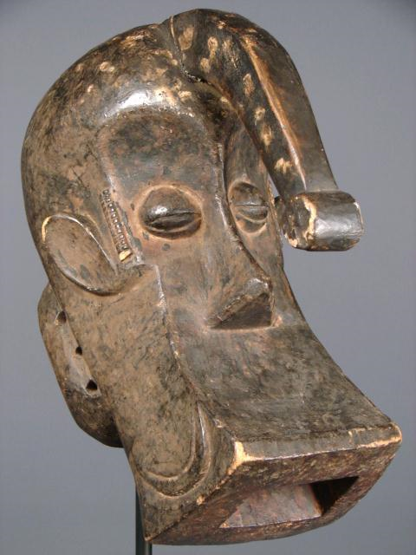

  
Fig. Afr-Nigeria-Abakaliki-Igbo-Izi-Elephant Spirit Mask-Ogbodo Enyi-late 19th c

Case No.: 6

**Accession No.**

**Formal Label:** Afr-Nigeria-Abakaliki-Igbo-Izi-Elephant Spirit Mask-Ogbodo Enyi-late 19th c

**Display Description:**

A number of tribes all linguistically related inhabit the Cross River area on the border between Nigeria and Cameroon. This mask is probably from the Abakaliki area in the North Eastern part of the Niger River delta, which is an area of forest and swamp where the Igbo-Izi people live. The Elephant Spirit Mask or Ogbodo Enyi is used to avert evil spirits and bad luck in a masquerade performance often associated with a significant life event. The mask combines elephant and human forms in one powerful and striking, abstract conception.

**LC Classification:**

**Date or Time Horizon:**

**Geographical Area:** southern Nigeria

**Map:**

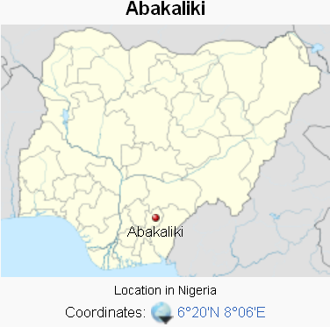

**GPS coordinates:** 

**Cultural Affiliation:**

**Media:**

**Dimensions:**

**Weight:**

**Condition:**

**Provenance:**

**Discussion:**

**References:**

Abakaliki is made up of three [Clans](http://en.wikipedia.org/wiki/Clans) namely [Ezza](http://en.wikipedia.org/wiki/Ezza) Ezekuna, [Izzi](http://en.wikipedia.org/wiki/Izzi) and [Ikwo](http://en.wikipedia.org/wiki/Ikwo). It has estimated population of 141,438 according to the 2006 census (["The World Gazetteer"](http://www.world-gazetteer.com/wg.php?men=gpro&des=gamelan&geo=346806811). Retrieved 2007-04-03.).

and used to avert evil spirits and bad luck in a masquerade performance often associated with a significant life event. The mask combines elephant and human forms in one powerful and striking, abstract conception.

**Igbo people**, also referred to as the **Ibo(e)**, **Ebo(e)**,[[9]](http://en.wikipedia.org/wiki/Igbo_people" \l "cite_note-jamaicaigbo-9)[[16]](http://en.wikipedia.org/wiki/Igbo_people" \l "cite_note-18)[[17]](http://en.wikipedia.org/wiki/Igbo_people" \l "cite_note-eboe-19) **Eboans**[[18]](http://en.wikipedia.org/wiki/Igbo_people" \l "cite_note-20) or **Heebo**[[19]](http://en.wikipedia.org/wiki/Igbo_people" \l "cite_note-21) ([Igbo](http://en.wikipedia.org/wiki/Igbo_language): *Ndị Igbọ*) are an [ethnic group](http://en.wikipedia.org/wiki/Ethnic_group) living chiefly in southeastern [Nigeria](http://en.wikipedia.org/wiki/Nigeria). They speak Igbo, which includes various [Igboid languages](http://en.wikipedia.org/wiki/Igboid_languages) and dialects;[[20]](http://en.wikipedia.org/wiki/Igbo_people" \l "cite_note-dialect-22) today, a majority of them speak [English](http://en.wikipedia.org/wiki/Nigerian_English) alongside Igbo as a result of [British colonialism](http://en.wikipedia.org/wiki/British_Empire).[[21]](http://en.wikipedia.org/wiki/Igbo_people" \l "cite_note-23) Igbo people are one of the largest and most influential ethnic groups in Nigeria.[[22]](http://en.wikipedia.org/wiki/Igbo_people" \l "cite_note-24) Due to the effects of [migration](http://en.wikipedia.org/wiki/African_Diaspora" \l "Dispersal_through_migration) and the [Atlantic slave trade](http://en.wikipedia.org/wiki/Atlantic_slave_trade), there are descendant ethnic Igbo populations in countries such as [Cameroon](http://en.wikipedia.org/wiki/Cameroon)[[4]](http://en.wikipedia.org/wiki/Igbo_people" \l "cite_note-Forrest_1994_272-4) and [Equatorial Guinea](http://en.wikipedia.org/wiki/Equatorial_Guinea),[[7]](http://en.wikipedia.org/wiki/Igbo_people" \l "cite_note-Mwakikagile_2006_86-7) as well as outside Africa. Many [African Americans](http://en.wikipedia.org/wiki/African_American) and [Afro Caribbeans](http://en.wiktionary.org/wiki/Afro-Caribbean) are of Igbo descent. Nigerian [Chinua Achebe](http://en.wikipedia.org/wiki/Chinua_Achebe)'s [*Things Fall Apart*](http://en.wikipedia.org/wiki/Things_Fall_Apart) is one of the most popular novels to depict Igbo culture and changes under colonialism. Certain conflicts with other Nigerian ethnicities led to the Igbo-dominant [Eastern Nigeria](http://en.wikipedia.org/wiki/Eastern_Nigeria) seceding from Nigeria to create the independent state of [Biafra](http://en.wikipedia.org/wiki/Republic_of_Biafra). The [Nigerian-Biafran war](http://en.wikipedia.org/wiki/Nigerian-Biafran_war) (6 July 1967 – 15 January 1970) broke out shortly after. With their defeat, the Republic of Biafra was reabsorbed into Nigeria.[[27]](http://en.wikipedia.org/wiki/Igbo_people" \l "cite_note-29) [MASSOB](http://en.wikipedia.org/wiki/MASSOB), a sectarian organization formed in 1999, continues a non-violent struggle for an independent Igbo state.[[28]](http://en.wikipedia.org/wiki/Igbo_people" \l "cite_note-30) In rural areas in Africa, the Igbo are mostly farmers. Their most important crop is the [yam](http://en.wikipedia.org/wiki/Yam_(vegetable)); celebrations are held annually to celebrate its harvesting.[[23]](http://en.wikipedia.org/wiki/Igbo_people" \l "cite_note-yam-25) Other staple crops include [cassava](http://en.wikipedia.org/wiki/Cassava) and [taro](http://en.wikipedia.org/wiki/Taro).[[24]](http://en.wikipedia.org/wiki/Igbo_people" \l "cite_note-brit1-26)

**Igbo-Ukwu** ([Igbo](http://en.wikipedia.org/wiki/Igbo_language): Great [Igbo](http://en.wikipedia.org/wiki/Igbo_people)) is a town in the [Nigerian](http://en.wikipedia.org/wiki/Nigeria) state of [Anambra](http://en.wikipedia.org/wiki/Anambra) in the southeastern part of the country. It had a metalworking art that dates to the 9th or 10th century, before other known bronze working areas. The first site, called *Igbo Isaiah*, was uncovered in 1938 by Isaiah Anozie a local villager, who stumbled upon the bronze works while digging beside his home. Subsequent excavations by [Thurston Shaw](http://en.wikipedia.org/w/index.php?title=Thurston_Shaw&action=edit&redlink=1) in 1959 resulted in the discovery of two other sites, *Igbo Richard* and *Igbo Jonah,* containing the remains of an ancient culture.. Three sites have been excavated, revealing hundreds of ritual vessels and regalia castings of bronze or leaded bronze that are among the most inventive and technically accomplished bronzes ever made. The people of Igbo-Ukwu, ancestors of present-day [Igbo](http://en.wikipedia.org/wiki/Igbo_people), were the earliest [smithers](http://en.wikipedia.org/wiki/Smithers) of copper and its alloys in West Africa, working the metal through hammering, bending, twisting, and incising. They are likely among the earliest groups of West Africans to employ the lost-wax casting techniques in the production of bronze sculptures. Oddly, evidence suggests that their metalworking repertory was limited and Igbo smiths were not familiar with techniques such as raising, soldering, riveting, and wire making, though these techniques were used elsewhere on the continent, Artifacts have included [jewelry](http://en.wikipedia.org/wiki/Jewelry), [ceramics](http://en.wikipedia.org/wiki/Pottery), a corpse adorned in what appears to be [regalia](http://en.wikipedia.org/wiki/Regalia), and many assorted [bronze](http://en.wikipedia.org/wiki/Bronze), [copper](http://en.wikipedia.org/wiki/Copper), and [iron](http://en.wikipedia.org/wiki/Iron) objects. Some of these contain materials that are evidence of a long-distance trading system going to Egypt. (Apley, Alice. ["Igbo-Ukwu (ca. 9th century)"](http://www.metmuseum.org/toah/hd/igbo/hd_igbo.htm). Metropolitan Museum of Art. Retrieved 2008-11-23.)

